Chapter one lab exercise

Introduction: Basic Terminologies in Java programming language
Alike to natural languages, formal languages do also have their own glossary. As one of the formal languages, Java has its own basic terminologies and definitions. To this end, Java students ought to understand the exact meaning and/or concept of the following common programming terminologies. I have tried to put some Amharic statements hopping that they may help the students better understand the concepts clutched under each terminology.

Program /የኮምፒዩተር ቀመር/:- is an organized list of instructions that, when executed, causes the
computer to behave in a predetermined manner. የኮምፒዩተር ቀመር መድበሇ ትእዛዛት ነው። ይህም የትእዛዛት ቅዯም ተከታሊዊ ስብስብ ማሇት ነው። እያንዲንደ ትእዛዝ ኮምፒዩተሩ ምን ማድረግ እንዲሇበት የሚጠቁም ዓረፍተ ነገር ነው።

Example:
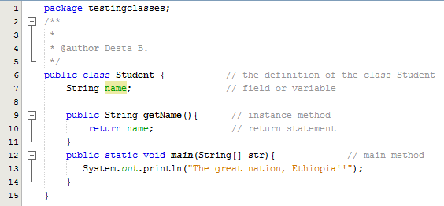

Fig-1: Content of a computer program
ከሊይ የምናየው ቀመር (program) 15 ትእዛዛት (instructions) ይዟሌ። ኮምፒዩተሩ እነዚህ ትእዛዛትን በቅዯም ተከተሌ በመተግበር አንድ የተሟሊ ተሌእኮ ይፈፅማሌ። በመሆኑም የእንዱህ ዓይነት ትእዛዛት መድበሌ (ስብስብ) የኮምፒዩተር ቀመር ይባሊሌ።
Array /ዝርዝር/፡- Array is a list of data values of the same type, any element of which can be referenced by an expression consisting of the array name followed by an indexing expression. Arrays are part of the fundamentals of data structures, which, in turn, are a major fundamental of computer programming.
የአንድ ዓይነት ምድብ ያሊቸው ነገሮች ዝርዝር ማሇት ነው። የተመሳሳይ ነገሮች ድርድር ማሇት ነው። በዝርዝሩ ሊይ ያለ ነገሮች ቅዯም ተከተሌ የሊቸውም። ሇምሳላ፡ ሀ = {55፣32፣71፣42፣86} ። ይህ ስሙ ሀ የሚባሌ ድርድር/ዝርዝር/ ነው። አራት አባሊትም ይዞዋሌ። እነዚህም ሀ[0]፣ ሀ[1]፣ ሀ[2]፣ ሀ[3] በማሇት ሌንጠራቸውም ሌንጠቀማቸውም እንችሊሇን። የዝርዝሩ አባሊት ጠቋሚ /index/ የሚጀምረው ከ ዜሮ ነው።

Example:
int[] arr; // this is an array declaration. In this example arr is a reference variable pointing to the memory where the list exists. The int[] is the data type telling that the type of the content of the array is only integer.
Class/መዯብ/፡- Class is a named template or descriptor for a set of objects that share the same attributes (fields), behaviors (methods) and relationships. It models /abstracts/ a real world entity.

አንድ ዓይነት መገሇጫዎች (attributes) ፣ ተግባራት (behaviours) እና ግንኝነቶች (relationshiops) ሇሚጋሩ ኣካሊት(objects) የሚሰጥ የወሌ መጠርያ ስም ነው። ሇምሳላ፡- ኳስ የሚሌ መዯብ የእግር ኳስ፣ የመረብ ኳስ፣ የእጅ ኳስ፣ የሕፃናት መጫወቻ ኳስ እና የመሳሰለት ሁለ ያጠቃሇሇ የጋራ መጠርያ ስም ነው።

class Student  {  ……  } | This is the declaration of the class. Note that a class should be declared using the keyword „class‟.
class Student  {  int age;  public int getAge(){ return age;  } | Here:  class – is a keyword used to declare a class in java. Student – is the user-defined name of the class int – is data type of the field.  age – is user-defined name of the field. public - is an access modifier getAge() – is the name of the method  {…} - used to enclose body of a given block.  return - is a keyboard in java used to return the value returned by a certain functions/methods and the flow control.
Character /ቀሇም/:- is a general name for all letters, digits, punctuation marks and other symbols.
ቀሇም ማሇት በቀመሩ ውስጥ የምንፅፈው ማንኛውም ፊዯሌ ወይም ምሌክት ነው። ሇምሳላ፡- &, @, %, 1, 4, 2, a, v, n, ?, \, k, p, ...

Comment /አስተያየት/:- is a remark (human-readable-only explanation) in the source code which does not affect the behavior of the program. It is ignored by the compiler. የኮምፒዩተር ቀመር/program/ በመንፅፍበት ጊዜ ሇእያንዲንደ መምሪያ/Instruction/ ሇማብራራት የሚጨምሩት ማብራርያ ነው። በመሆኑም በአርታዔ ቀመር /compiler/ የሚታይ
እና የሚተረጏም አይዯሇም።
// this is a single comment
/* */ is the multiline comment in Java.
Variable /የዲታ መያዣ/:- is a named memory location in which a program can store intermediate results and from which it can read them for use.
ይህ የዲታ መያዣ ነው። ሇጊዜው የሚይዘው ዲታ ስሇማይታወቅ ተተኪ /variable/ ተባሇ። ማንኛውም የኮምፒዩተር ቀመር የሚሰራው
ዲታ ሊይ ነው። ቀመሩ ዲታውን ጠቃሚ መረጃ (information) እስኪሆን ድረስ የማቀነባበር፣ የማዯባሇቅ፣ የማንዯባሇሌ፣ የመቀመር ወዘተ ስራ ይስራሌ። ታዱያ ዲታው የሚያገኘው ከኪ ቦርድ፣ ከኔትዎርክ፣ ከራሱ ሃርድ ዱሰክ መዛግብት ወዘተ ሉሆን ይችሊሌ። ይህ ዲታ ቀመሩ

ሉጠቀምበት በሚችሌ መሌኩ የሚቀመጠው ዯግሞ በዲታ ማስቀመጫዎች (data structures) ውስጥ ነው። ከእነዚህ ዲታ ማስቀመጫዎች አንደ ይሄው ‘የዲታ መያዣ’ ያሌነው ነው።
Example:-
double gpa; // Now, gpa is the name of the memory (i.e. the variable).
// double:- indicates two basic things – the dimension of the variable and the
// type of data that can be stored in variable gpa.

Keyword /ቁሌፍ ቃሌ/:- is a reserved word used to identify a specific command, function etc in the programming language. በአንድ የኮምፒዩተር ቀመር ቋንቋ ውስጥ የሚገኙ የቋንቋው የራስ ቃልች ‘ቁሌፍ ቃሌ’ ይባሊለ።
Example:- int, for, while, break, continue, do, static, final, public, etc.

Constant /አይቀየሬ/:- Constant is a numeric or string value that is not calculated and, therefore, does not change. In Java, constant variables are declared using the keyword final.
የኮምፒዩተር ቀመር በምንፅፍበት ወቅት የምንጠቀምበት፣ ዋጋው የማይቀያየር የዲታ መያዣ ‘አይቀየሬ’ ይባሊሌ። ሇምሳላ፡- የሒሳብ ቀመሮች በምንሰራበት ወቅት የπ ዋጋ 3.14 በማድረግ ነው። ይህ ዋጋ መቼውም የማይቀየር የπ ዋጋ ነው። ስሇዚህ በኮምፒዩተር ቀመር ቋንቋ ሲንገሌፀው ዋጋው የማይቀያየር የዲታ መያዣ ‘አይቀየሬ’ እንሇዋሇን።

Example:-
final double PI = 3.14
final float gravity = 9.8

Data type /የዲታ ዓይነት/:- is a classification or category of various types of data, which states the possible values that can be taken, how they are stored, and what range of operations are allowed on them. It determines two things about the data stored in a variable:
- the space (memory) given to the data
- the type of the data that can possibly be stored in that variable.
ኮምፒዩተር የሚሰራው ስራ በሙለ ዲታ ሊይ ያጠነጠነ ነው። እነዚህ ዲታዎች የተሇያዩ ዓይነቶች ናቸው። በመሆኑም ‘የዲታ ዓይነት’ ማሇት በአንድ የዲታ መያዣ ወይም አይቀየሬ ሊይ የምናስቀምጠው ዲታ፣ ዓይነቱ የሚገሌፅሌን ቁሌፍ ቃሌ ነው። ከዚህ በተጨማሪ በተተኪው (በዲታ መያዣው) ሊይ የሚቀመጠውን ዲታ መጠኑ (dimension) ምን ያህሌ ቢት/ባይት እንዯሆነ ይገሌፅሌናሌ።
Function or method /አስላ/:- Function (also called method in java) is a piece of code that operates as a single logical unit. A function is called by name, accepts optional input parameters, and returns a status and optional output parameters. It simulates the natural orders seen in human beings. i.e., it operates by taking an input from the caller, processing the input, and finally returns its processed

value back to the caller. In short, functions simulate human beings, factories and any machine that works following the basic operation-patterns namely: Input → process → output.
ሇስላት የሚጠቅሙት ግብኣቶች/parameters/ በመውሰድ አንድ ስላት ሰርቶ የሚመሌስ፣ ከቀመሩ ከማንኛውም ክፍሌ ሉጠራ የሚችሌ የቀመሩ ኣካሌ ‘አስላ’ ይባሊሌ። አስላ ሁሇት ዋና ዋና ክፍልች አለት። እነርሱም የአስላ ስርዓት /method definition/ እና የአስላ አሰሪ (ወይም ጠሪ) /method call/ ናቸው።
Example:-

 | Method definition /የአስላ ስርዓት/ | መግሇጫ
11 | int add (int firstNum, int secondNum)  { | ይህ የአስላ ስርዓት ነው፡፡ ሁሇት ክፍልች አለት፡ አንዯኛው (11)  ተብል የተመሇከተው የአስላ መሇዮ(method signature) እየተባሇ የሚጠራው ሲሆን ሁሇተኛው ዯግሞ (22) ተብል  የተመሇከተው (የአስላ ሰውነት) method body የሚባሇውን ነው።  የአስላ መሇዮ ሶስት ነገሮችን የያዘ ነው፡- የመሌስ ዓይነት (return type)፣ የአስላ ስም (method name) እና የአስላ ግብአት (method parameter) ናቸው።  የአስላ ሰውነት አስላው ግብአቶችን ተቀብል የሚያሰሊበት  የስላት ትእዛዛት የያዘ (working instructions) በማዕቀፍ ቅንፎች /{….}/ የተከበበው ዋና ሰውነቱ ነው።  የመሌስ ዓይነት (return type)፡- አስላው ስላቱን ሰርቶ የሚመሌሰው መሌስ፣ የመሌሱ ዓይነት የሚገሌፅ ነው።  የአስላው ስም (method name)፡- የአስላው ስያሜ ነው።  ማንኛውም መሇዮ (identifier) መሆን ይችሊሌ።  የስላት ግብአት (method parameter)፡- አስላው ሇሚያካሂዯው ስላት የሚወስዯው ግብአት ማሇት ነው። ነገር ግን አስላው ግብአት ሳይወስድም መስራት ይችሊሌ።
22 | int summation = 0;  summation = firstNum + secondNum; return summation;  }

Identifier /መሇዮ/:- Identifier is a formal name used in source code to refer to a variable, method, class, package, etc.
የኮምፒዩተር ቀመር ፀሓፊው በቀመሩ ውስጥ የሚፅፋቸው ማንኛውም የዲታ መያዣ፣ የአይቀየሬ፣ የዲታ ዓይነት፣ የአስላ ወዘተ ስሞች ‘መሇዮ’ እንሊቸዋሇን። መሇዮዎች በምንፅፍበት ጊዜ እንዯ የኮምፒዩተሩ ቋንቋ የምንከተሊቸው ሕጎች አለ። በ ጃቫ ሁሇት ሕጎች አለን። ማንኛውም መሇዮ በፊዯሌ ወይም በግርጌ ጭረት(underscore) ብቻ መጀመር አሇበት። ከመጀመርያው ቀጥል የሚፃፉት ሦስት ነገሮች [ማሇትም ፊዯሊት፣ቁጥሮች ወይም የግርጌ ጭረት] ብቻ ናቸው።
ሇምሳላ፡

isSecondYearStudent ✓  _isSecondYearStudent ✓  isSecond YearStudent ✗ | 2ndIsSecondYearStudent ✗  is2nd_YearStudent ✓  is2ndYearStudent ✓

Literal /ጥሬ ዋጋ/:- is a value written into the source code of a computer program.
በአንድ የዲታ መያዣ ውስጥ የዲታ ዓይነቱ መሰረት በማድረግ የምናስቀምጠው ዋጋ ‘ጥሬ ዋጋ’ እንሇዋሇን። ሇምሳላ፡- int a = 5; (1)
String str = ‚I am student of IoT-SCEE‛; (2)
በቁጥር (1) የተመሇከተው ዋጋ /5/ የኢንተጀር ጥሬ ዋጋ ይባሊሌ።
በቁጥር (2) የተመሇከተው /I am student of IoT-SCEE/ የሚሌ ዋጋ የስትሪንግ ጥሬ ዋጋ ይባሊሌ።
Loop /ጥምጥም/:- is a sequence of instructions that should be executed repeatedly until or while a particular condition is satisfied.
ቀመሩ አንድን ነገር መሊሌሶ እንዱሰራሌን ስንፈሌግ የምንጠቀምበት የቀመሩ አንደ ሰዋስው (programming construct) ነው። ይህም አንድ ሂዯት ወይም ተግባር ብዙ ጊዜ ተዯጋግሞ እንዱሰሊ የሚያስችሌ ነው። ሇዚህ ዓሊማ የምንጠቀምባቸው የቀመር የጥምጥም ዓይነቶች ሦስት ናቸው። እነዚህም፡- for loop, while loop, do while loop ይባሊለ።
Object /አካሌ/:- Object, in object-oriented programming, is an instance of a class. An object comprises data and methods that act on the data, and is treated as a discrete entity. Entity is anything in the physical world that can be described by its attributes and behaviors (activities).
በሰው ዘንድ በገሃደ ዓሇም ህሌውናውን የታወቀ፣ በሰው ቋንቋ ሉገሇፅ የሚችሌ ቁስ አካሌ ወይም ተጨባጭ ነገር ነው።



ምድብ የጃቫ ፕሮግራም ትንሹ ክፍሌ ነው። የገሃደ ዓሇም ነገርን ይወክሊሌ። ስሙም የገሃደ ዓሇም ነገር ስም ነው። በውስጡ ሁሇት ዋና ዋና ነገሮች ይይዛሌ። ይሄውም የገሃደ ነገር መገሇጫዎች የነበሩ የምድቡ fields፣ የገሃደ ነገር ተጋባራት የምድቡ methods ይሆናለ። በመሆኑም ምድብ ሁሇት የራስ አባሊት /logic al members/ አለት። እነርሱም fields እና methods ናቸው።
ምድብ ተማሪ
{
መገሇጫዎች (fields)
ተግባራት (methods)
}

Real world Object or Entity /Ro/
በግሃደ ዓሇም የምናውቃቸው ነገሮች ስም አሊቸው። በቋንቋ ስንገሌፃቸውም በሁሇት ነገሮቻቸው ነው። ይሄውም
በመገሊጫዎቻቸው/attributes/ እና በተግባሮቻቸው /behaviors/ ብቻ ነው። ሇምሳላ፡- ተማሪ አንድ ግሃድ ነገር
/real entity/ ነው። ስሙ ተማሪ ነው። መገሊጫዎቹም ዕድሜ፣ መታወቂያ ቁጥር፣ ውጤት፣ ት/ት ክፍሌ፣ ወዘተ ናቸው። ተግባራቱም ማንበብ፣ ሪፓርት መፃፍ፣ መመራመር፣ መብሊት፣መተኛት፣ መማር፣ ወዘተ ናቸው።

Real world Object / entity
(R_{o})
ምድብ /class/
ምድብ
/Class/

Programming Object
(P_{o})
Programming Object /Po/
ተማሪ ተ = አዱስ ተማሪ(); // በዚህ መሌኩ አንድ ተማሪ ተፈጠረ።



ምድብ (class) በገሃደ ዓሇም ያሇ አንድን ነገር (entity) አርቅቆ (abstraction) እና ወክል የሚፃፍ የጃቫ ቀመር ትንሹ ክፍሌ
/automic unit/ ነው። የቀመሩ ኣካሌም (Object) የሚፈጠረው ይሄው ከዚሁ ምድብ ነው። ምድብ የመባለ ዋና ምክንያትም አንድ ዓይነት መገሇጫዋችና አስላዎች የሚጋሩ፣ ተመሳሳይ ምድብ ውስጥ ሉመዯቡ የሚችላ አካሊት (ገሃዶች - instances) ስሇሚፈጠሩበት ነው። በአጠቃሊይ ከአንድ ምድብ ብዙ የምድቡ ገሃዶች የሆኑት አካሊት (instances or objects) መፍጠር ይቻሊሌ።
String /ፅfhፍ/:- String is sequence of characters.
የቀሇሞች ስብስብ ነው። ባዶ ወይም አንድ ወይም ከአንድ በሊይ ቀሇሞች ሉይዝ ይችሊሌ።
Field /መገሇጫ/:- is a variable associated with an object or class. የአንድ ኣካሌ (object) መገሇጫ ነዉ።

Lesson-1. Setting up your Java development environment in your computer and writing, compiling and running simple java programs
Objective: at the end of this laboratory session, you will be able to:
- Configure a java environment (platform) so that you can write, compile and run java programs in any computer.
- Write, compile and run very simple java programs and understand each of their parts clearly.
Lesson Prerequisite:
Students! Before you sit for this lesson in the laboratory, make sure that you have studied:
- The difference between Java JDK and Java JRE
- The various tools packed in the JDK and their role in running a given java application.
- The phases that any java application passes thorough for execution.
- The various tools bundled in JDK that are used for compiling, debugging and running java app
- The syntax and semantics of java class anatomy discussed in class!!
- The syntax of declaring and defining java class!
- Commonly used classes such as String, System etc in the package java.lang

Lesson-1 Activity

Task-1:- Install and configure the Java platform in your computer.

In order to write and run Java program, you need to install and configure the Java platform (i.e., the Java Development K it- JDK) on your computer system.
To configure the JDK, you have to set the JAVA_HOME environment variable to the root location of the JDK installation directory in your computer. For Example, assume that your Java is installed in C:\Program Files\Java\jdk1.6.0_06; where jdk1.6.0_06 is the version of the JDK you installed. Then, use either of the following ways to set the JAVA_HOME environment variable:
- By writing the following statement in the command prompt: C:\> set JAVA_HOME= C:\Program Files\Java\jdk1.6.0_06

- Right click on My Computer→ Properties→Advanced System Settings→Environment Variables; in the system variables part click New button and then write JAVA_HOME in the variable name field and C:\Program Files\Java\jdk1.6.0_06 in the variable value. Click OK on the path edit box and OK on the Environment Variables box. The new setting will go into effect next time you run Command Prompt.
Next set the PATH environment variable to include the JDK bin directory. The PATH variable tells the operating system where to find the java interpreter and the javac compiler. Use either of the above two ways. If you choose to use the first way, the statement you should write in the command prompt is: C:\> set PATH=%PATH%;%JAVA_HOME%\bin

To make sure that you have configured the JDK successfully, use the java -version command to see the JDK version and the path it is installed in.
Task-2: Open either of the java editors discussed in class [such as notepad, JCreator, etc] and then write the following simple program.
Here, please be sure to name the text file as OopStudBiT.java (Note: please name your class in the program with your own name by making the first letter of your name capital letter). Java program is case sensitive, so if you type the code in yourself, pay particular attention to the capitalization (Eg. Write OopStudBiT instead of oopStudBiT to name your java class).
//A very simple java program which prints first and second name of the programmer.

public class OopStudBiT{ // line-1
public static void main(String[] ethiopia) { // line-2
String firstName = "Yohannes"; // line-3
String secondName = "Zekarias"; // line-4
System.out.println("Your Full Name is:" + firstName+""+secondName); // line-5
}
}

Now, compile and run the program and you will see the following output.
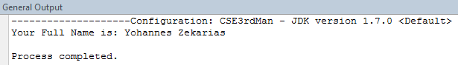

Code analysis on the above program
- In Line-1:
  - public :- is a keyword used to indicate that the class OopStudBiT can be accessed publically by any class from anywhere.
  - class:- is a keyword used to declare a class in java.
  - OopStudBiT: - is the name of the class. It can be any legal identifier with one or group of words.
- In line-2:
  - public :- tells that the main method can be called from within the class or anywhere outside of the class.
  - static:- tells that the method is associated with its class and not with the instances of its class.
  - void:- is the return type of the method. It means that the method returns nothing.
  - main:- is the name of the method.
  - ():- these brackets are method markers. They are used to indicate the input (parameters) of the method.
  - String:- is the built- in class in the java library which represents collection of characters. It is found in the package java.lang
  - [] :- is an array marker. Now, see that the main() method takes array of strings as an input (as its parameter).
  - ethiopia:- is name of the reference variable of the parameter array.
- In line-3:
  - String :- is a class name. Classes are data types in java. So, it is the data type of the variable
firstName.
  - firstName:- is reference variable name. It is user defined name. It can be any words but should be legal identifier.
▪ = :- is the assignment operator. It is assigning the value in the right of it to the variable to the right side of it.
  - "Yohannes":- is a string literal. It is being assigned to a string variable on the left of the assignment operator.
  - ;(semicolon) :- is end of statement marker. In Java, all simple statements end with a semicolon.
- In line-4:
  - This is the same as what is in line-3. So, try to understand it as what is there in line

- In line-5:
  - System :- is name of abuilt- in class in Java library. It contains the standard input/out streams. It is found in the package java.lang
  - .(dot) :- is an access operator. It is used to access members (fields and methods) of a class or an object.
  - out :- is a static reference variable to the standard output stream object of type PrintStream.
  - print() :- is an instance method defined inside of the PrintStream class. It is an overloaded method with different parameters. It has also another version of it s type called println(). The suffix ln means „line‟. By this, println is meant to print the output in new line.
  - "Your Full Name is:":- is a literal string. Everything under double quotes is a literal string.
▪ +(plus sign):- is a concatenation operator. When it comes between non-string numeric values, it is a mathematical addition operator. However, if either of its operands is String, then it becomes a concatenation operator.

Task-3:- Write the following java program on notepad and run it from the command prompt.
Create a temporary folder C:\BiTScee. Using Notepad or another text editor, create a small Java file OopStudBiT.java with the following text:
public class OopStudBiT
{
public static void main(String[] args)
{
System.out.println("OOP, BiT-SCEE!");
}
}

    - አስተውሌ! አስተውሌ! አስተውሌ! Java is case-sensitive!

Lesson-1 Exercises
- Write a program that accepts two numbers from the keyboard. The main() method should first accept the two numbers and then passes these values to methods named add(), sub(), mul() and div(), to calculate the sum, difference, product and quotient of the numbers, respectively. Finally, the main() method should accept the returned result and display it on the consol. [Hint: your java program will have five methods of which one is the mandatory main() method. ]

- Write a program that calculates the area of a rectangle. The main() method should first accept the width and height of the rectangle and then passes these values to method named rectangleArea(). Method rectangleArea() calculates the area of the rectangle using the
formula width*height and return the result. main() method should accept the returned result and display it.
- What do you think is the output of the following code fragmentation?
final int N = 100;
for (int i=0;i<N/2;++i){ for(int j=N;j>=2;--j){
Sytem.out.println(“I am learning Java!!”);
}
Sytem.out.println(“I found it simple, portable and secured!!”);

}
  - how many “I am learning Java” is printed?
  - how many “I found it simple, portable and secured!!” is printed?

Lesson-2. The structure /Anatomy/ of a Java class and accepting input from user
Objective: at the end of this laboratory session, you will be able to:
- Implement and understand the java class anatomy.
- Write simple java application which accepts inputs from the keyword.
- You will see some mechanisms of accepting input from keyword.

Here the Java class anatomy which we will try to apply it throughout the course.

Points to be remembered:
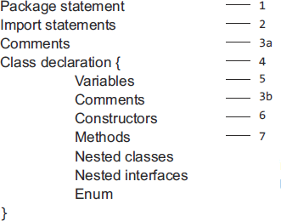
    - Only comments can exist everywhere in the program.
    - Package statement, if it exist, should be the first line of code in the program. And we can have only one package statement in a program.
    - Import statement(s), if they exist, should follow the package statement. They can possibly be many lines of codes.
    - Except the package and import statements, every code should be written inside of a class.

How to accept input from the keyword?

The following are some of the ways that Java offers us to accept input from a standard input device, the keyboard.
- Using the Scanner class
One of the strengths of Java is the huge libraries of code available to you. This is code that has been written to do specific jobs. All you need to do is to reference which library you want to use, and then call a method into action. One really useful class that handles input from a user is called the Scanner class. The Scanner class can be found in the java.util library. To use the Scanner class, you need to reference it in your code. This is done with the keyword import.
import java.util.Scanner;

The import statement needs to go just above the Class statement:
import java.util.Scanner; public class StringVariables
{
…
}
This tells java that you want to use a particular class in a particular library - the Scanner class, which is located in the java.util library [i.e., the package where the class is located].

The next thing you need to do is to create an object from the Scanner class. (A class is just a bunch of code. It doesn't do anything until you create a new object from it.)

To create a new Scanner object the code is this:
Scanner userInput = new Scanner( System.in );

So instead of setting up an int variable or a String variable, we're setting up a Scanner variable. We've called ours userInput. After an equals sign, we have the keyword new. This is used to create new objects from a class. The object we're creating is from the Scanner class. In between round brackets we have to tell java that this will be System Input (System.in).

To get the user input, you can call into action one of the many methods available to your new Scanner object. One of these methods is called next(). This gets the next string of text that a user types on the keyboard:

የቴክኖልጂ ትምህርት በኢትዮጲያኛ ብንማረውና ብንረዲው፣
በኢትዮጲያኛ ብንተነትነው፣ ሇኢትዮጵያ እናውሇዋሇን!

String firstName;
firstName = userInput.next( );
So after our userInput object we type a dot to access all instance fields and methods of the Scanner class.
String firstName;
System.out.print("Enter your first name: ");
firstName = userInput.next();
Notice that we've used print rather than println like last time. The difference between the two is that println will move the cursor to a new line after the output, but print stays on the same line.
We'll add a prompt for a second name, as well:
String secondName;
System.out.print("Enter your family name: "); secondName = userInput.next( );

This is the same code, except that java will now store whatever the user types into our secondName variable instead of our firstName variable.
To print out the input, we can add the following:
String full_name;
full_name = firstName + " " + secondName; System.out.println("You are " + full_name);

We've set up another String variable, full_name. We're storing whatever is in the two variables firstName and secondName. In between the two, we've added a space. The final line prints it all out in the Output window.
So, all together, your entire code looks the following code:

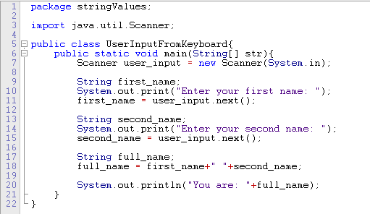
Now compile and run your program until your output window displays the following:
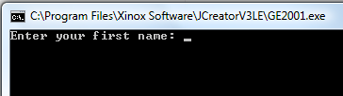

Java is now pausing until you enter something on your keyboard. It won't progress until you hit the enter key. Type a first name, and then hit the enter key on your keyboard.
After you hit the enter key, java will take whatever was typed and store it in the variable name to the left of the equals sign. For us, this was the variable called first_name.

The program then moves on to the next line of code:
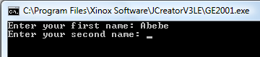

Type a second name, and hit the enter key again:

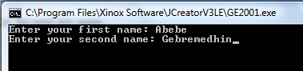
The user input has now finished, and the rest of the program executes. This is the output of the two names. The final result should like this:
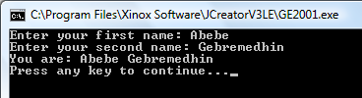

So we used the Scanner class to get input from a user. Whatever was typed was stored in variables. The result was then printed to the output window.

- Using the JOptionPane class

Another useful class for accepting user input, and displaying results, is the JOptionPane class. This is located in the javax.swing library. The JOptionPane class allows you to have input boxes like this one:
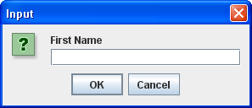

And message boxes like this:
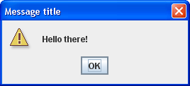

Let‟s see the change to our program above when we use JOptionPane class for accepting an input:

The first thing to do is to import the library/package we want to use:
import javax.swing.JOptionPane;

This tells java that we want to use the JOptionPane class, located in the javax.swing library.

You can start a new project for this, if you prefer not to adapt your previous code. (You should know how to create a new project by now. Just remember to change the name of the Class to a name of your conform word. We're going to have the class name InputBoxes for ours case. Our package name will be userinput.)

Add the import line to your new project, and your code window should look like something like this:

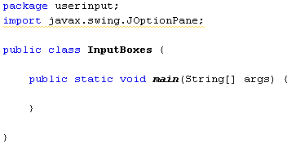

To get an input box that the user can type into, we can use the showInputDialog() method of JOptionPane. We'll store the input straight into a first name variable again, just like last time. So add the following line to your main method:

String first_name;
first_name = JOptionPane.showInputDialog("First Name");

And add the following code so that we can get the user's second name:

String second_name;
second_name = JOptionPane.showInputDialog("Family Name");

Join the two together, and add some text:

String full_name;
full_name = "You are " + first_name + " " + second_name;
To display the result in a message box, add the following:

JOptionPane.showMessageDialog( null, full_name );

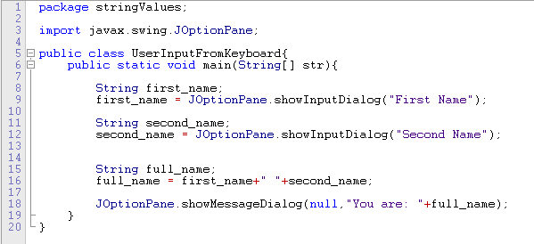
In between the round brackets we first have the word null. This is a java keyword and just means that the message box is not associated with anything else in the program. After a comma comes the text we want to display in the message box. The whole of your code should look like this:
Now compile and run your code. You'll see the First Name input box. Type something into it, then click OK:
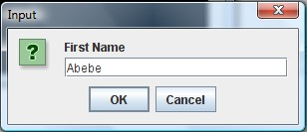

When the Second Name input box appears, type a second name and click OK:
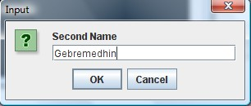

After you click OK, the message box will display:
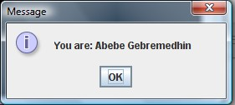

Click OK to end the program.

Lesson-2 Activity
Task-1: Open JCreator (or any editor of your preference) and write the following program.
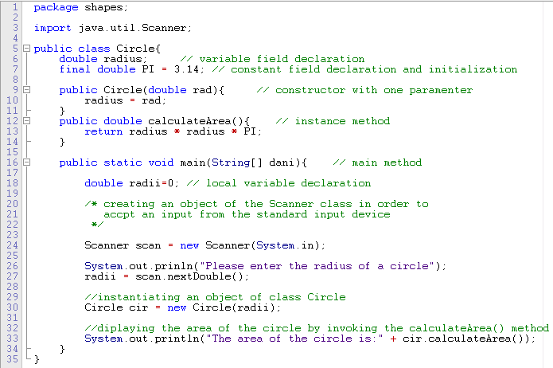
// the following program accepts the height and width of a rectangle and displays its area.
Fig-2. Sample code for lesson-2

Now, when you compile and run the above program, you will see the following output.

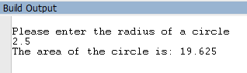

Code analysis on fig-2 above
- Line-1:- is the package statement. It is declaring the name of the package in which the byte code of the class resides. Java‟s package means simply folder or directory, where the byte code file (the
.class file created after compilation) resides. In this stateme nt:
  - package :- is the keyword used to define the name of the package.
  - shapes:- is the name of the package
- Line-3:- is an import statement. It is importing the Scanner class found in the package
java.util to our code so that we can make use of its members. In this statement:
  - import:-is a keyword used to include (to bring in) a class in found in another package to our source code. It is equivalent to the keyword „include‟le of C⁺⁺.
  - java:- is a name of a package (folder) where the subfolder util is found in.
  - util:- is a name of a sub-package (subfolder) found under the java package.
  - Scanner:- is the name of the wanted built- in class found in the indicated path.
Altogether, we can say that it is the path in the file system of the computer where the wanted class (in this case, the Scanner class) resides in. Its equivalent windows path writing style is java\util\Scanner.
- Line-5 :- is the declaration of the class that its name is Circle. Starting from line-5 down to line- 35 is the definition of the class. This class contains two fields (line-6 and line-7), one constructor (line-9 to line-11), and two methods (line-12 to line-14 and line-16 to line-34). Mind you that fields and methods are the only two logical members of a class.
- Line-24:- is instantiating (creating) an instance (an object) from the Scanner class. The new
keyword is used to create an object from a given class.
- Line-27:- is accepting a double value input from the keyword using the instance method nextDouble() of class Scanner. Since the nextDouble()is an instance method, it should be preceded by the name of its instance where it is found in.

Task-2:- Write a java program which receives a number and determine whether it is odd or even. (Hint: use the Scanner class for accepting an input).
Task-3:- Write a java program which calculates displacement of an object using the following formula: s = ut + ½ at². (Hint: use the JOptionPane class for accepting an input).

Lesson-2 Exercises
- Input boxes and Message boxes can be formatted further. Try the following for your Input boxes: showInputDialog("First Name", "Enter Your First Name"); showInputDialog("Second Name", "Enter Your Second Name");

- For your Message boxes try this:
showMessageDialog(null, full_name, "Name", JOptionPane.INFORMATION_MESSAGE);

- Instead of JOptionPane.INFORMATION_MESSAGE try these:
ERROR_MESSAGE PLAIN_MESSAGE QUESTION_MESSAGE WARNING_MESSAGE
- Input boxes are not just used for text: they can accept numbers as well. Write a program that
prompts the user for two numbers, the width of a rectangle and the height of a rectangle. Use a message box to calculate the area of the rectangle.
- The program will crash if you enter floating point values for the width and height. How would you solve this?
- When you have solved the above exercise, do you really want Integer.parseInt()? What else do you think you can use?
የዚህ መሌመጃ ጕርሻ [tip]:
You have to use the String variable to get your numbers from the user:
String breadth;
breadth = JOptionPane.showInputDialog("Rectangle Breadth");

However, you can't multiply two strings together. You need to convert the Strings to integers. You can convert a string to an integer like this:
Integer.parseInt( string_to_convert )
So you type Integer then a full stop. After the stop, type parseInt( ). In between the round brackets of parseInt, type the name of the string variable you're trying to convert.

For the message box, use concatenation:
"answer = " + area
You can use any of the MESSAGE symbols for your message box.
Set up an int variable for the area. You can then multiply and assign on the same line;
int area = Integer.parseInt( string_one ) * Integer.parseInt( string_two);
Lesson-3. Writing simple object-oriented programs with Java
Objective: at the end of this laboratory session, you will be able to:
- write an object-oriented java programs thereby understand how to instantiate an object and how to read/write data from/to an object.
NB: please apply the same fashion to solve all the exercises in this lesson. All of you should solve all problems given in this lesson.
Lesson Prerequisite:
Students! Before you sit for this lesson in the laboratory, make sure that you have studied:
- The syntax and semantics of java application anatomy discussed in class!!
- The syntax of declaring and defining java class!
- The logical members of a class (the fields and methods), the syntax of writing static fields, constants, instance fields, methods, etc.
- The static and non-static members of a class.

Important points to remember:
  - Class is a template to create an object. Many objects can be created from the same class. Object created from the same class are said to be „objects of the same type‟.
  - Class is a reference data type. For this reason, the variable declared using a class is called reference variable.
  - An object is created /instantiated/ from its class using the „new‟ operator.
  - Reference variable stores the reference of the object and not the object itself.

Lesson-3 Activity
Task-1:- Write a java program which adds even numbers between 0 and any positive integer number given by the user.
Here below is the code to the above program.

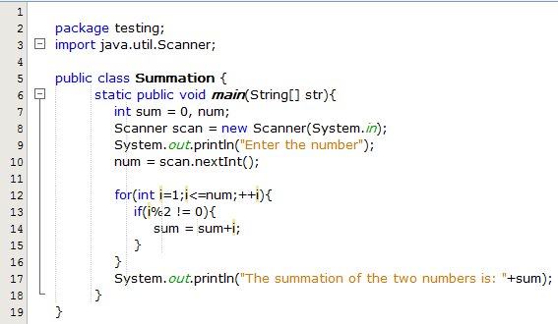
Task-2:- Write an object-oriented program which computes:
- area of triangle after the user has entered its height and base.
- area of triangle after the user has entered the three sides of triangle.
- area and circumference of a circle.
- volume and surface area of a sphere given radius of the sphere. [Note that volume =
¾π(radius)³ and area = 4π(radius)². Take π to be 3.14159265]
Task-3:- Write an object-oriented program which receives list of numbers and display the largest number.

Lesson-3: Exercises
- Write a java program which finds the average, maximum, minimum, and sum of three numbers given by the user.
- Write a java program which accepts radius of a circle and displays its area.
- Write a java program which reads 10 integers from the keyboard in the range 0 - 100, and count how many of them are larger than 50, and display this result.
- Write a java program which takes an integer from the user and display the factorial of that number.
- Write a java program which accepts a number and compute square root of the number
- Write a java program which accepts three numbers x, y and z and compute the following algebraic expression

  - 𝑟𝑒𝑠𝑢𝑙𝑡 = 2𝑥+𝑦
𝑧−2

  - 𝑟𝑒𝑠𝑢𝑙𝑡 = 2𝑥+√𝑦2+4𝑥𝑦
2𝑧
  - If x =10, y=2 and z=3, then what is the value of the following algebraic expression
    - x²+2y/z, assume data type of x, y and z is integer
ii. ++x - 2Y++ z*y
iii. 𝑥𝑦 +𝑥/𝑦
𝑧−2

- Write a java program which takes D number of days and displays the number of Y years, M months, W weeks and d days from the entered number D. (If entered value of D is 544, the output should be: 544 days is equal to 1 year, 5 months, 4 weeks, and 1 day).
- Write a java program which takes D number of days and displays the number of H hours, M minutes and S seconds from the entered number D. (If entered value of D is 544, the output should be: 544 days is equal to 6528 hours or 391680 or 23500800 seconds).

- Write a java program which calculates petrol (gas) consumption. It should accept the distance travelled (in kilometers) and the amount of petrol used (in liters) and compute the consumption in km/liter as well as in liters per 100 km. Write some helpful headings, so that your output will look like as follows:
Distance Liters used Km/L L/100Km
528 46.23 11.42 8.76
- Write a java program which accepts an integer and reverse digits
- Write a java program which computes sum of prime numbers between 0 and 1000. Your program which contains a method isPrime(int a) to check if the number is prime number.
- Write a java program which computes the following mathematical expressions.
  - 1+1/2+1/3+1/4+…1/15
  - 1! + 2! + 3! + 4! + …n!

30
c. ∑
𝑖 =1(𝑖 ) ∗ 2

Exercise of chapter two

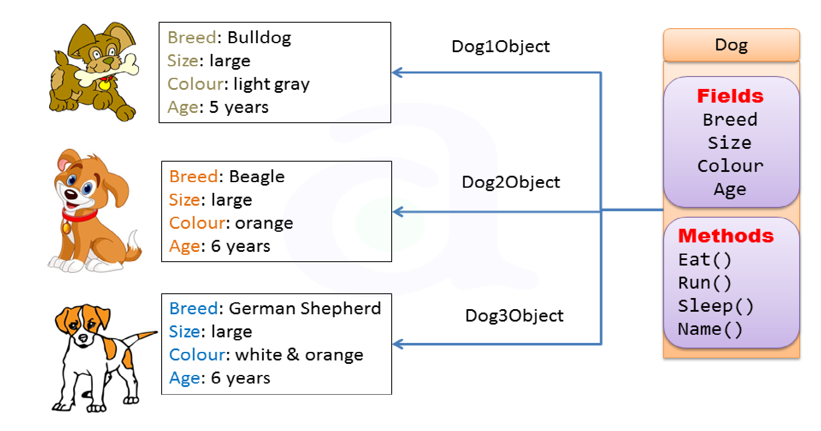

- Implement the above class using the concept of object and class
package classandobject;

public class Dog {

String breed;
String size;
String color;
int age;
public Dog(String breed,String size,String color,int age)
{
this.breed=breed;
this.size=size;
this.color=color;
this.age=age;
}
public String Eat(){
String eat="the dog usualy eats meat";
return eat;
}
public String Run(){
String run="the dog runs faster than human";
return run;

}
public String sleep(){
String sleep="the dog usualy sleeps in a day";
return sleep;

}
public String name(){
String name="brave dog";
return name;
}
public static void main(String[] args)
{
String b="buldog";
String s="large";
String c="black";
int age=5;
Dog o1=new Dog(b,s, c, age);
System.out.println("the breed of the dog is ="+o1.breed);
System.out.println("the size of the dog is ="+o1.size);
System.out.println("the color of the dog is ="+o1.color);
System.out.println("the age of the dog is ="+o1.age);

System.out.println(o1.Eat());
System.out.println(o1.Run());
System.out.println(o1.sleep());
System.out.println(o1.name());

Dog o2=new Dog("begle","large","orange",6);

System.out.println("the breed of the dog for object 2 is ="+o2.breed);
System.out.println("the size of the dog dog for object 2 is ="+o2.size);
System.out.println("the color of the dog dog for object 2 is ="+o2.color);
System.out.println("the age of the dog dog for object 2 is ="+o2.age);

}

}
- Write a Java program that defines the Circle class and creates/constructs/ three circle objects with radius entered from the keyboard and displays the radius and area of each of the three circles.
By two different class with the same package
public class simplecircle {
public double rad;
public simplecircle(double rad){
this.rad=rad;
}
public double area(){
return (22/7)*rad*rad;
}
public double perimeter(){
return 2*(22/7)*rad;
}
}

import java.util.Scanner;
public class testsimplecircle {
public static void main(String args[]){
double r=0;
Scanner scan=new Scanner(System.in);
System.out.println("enter three radius");

r=scan.nextDouble();
double radius=scan.nextDouble();
double r3=scan.nextDouble();
simplecircle o1=new simplecircle(r);
simplecircle o2=new simplecircle(radius);
simplecircle o3=new simplecircle(r3);

System.out.println("the value of the radius for obect 1="+o1.rad);
System.out.println("the value of the radius for obect 2="+o2.rad);
System.out.println("the value of the radius for obect 3="+o3.rad);
System.out.println("the area for object 1="+o1.area());
System.out.println("the area for object 2="+o2.area());
System.out.println("the area for object 3="+o3.area());

System.out.println("the perimeter of the circle for object 1="+o1.perimeter());
System.out.println("the perimeter of the circle for object 1="+o2.perimeter());
System.out.println("the perimeter of the circle for object 1="+o3.perimeter());
}

}

- Accessing members and methods of a person class

import java.util.Scanner;
public class personMethod {
// members of the class
String fullname;
int age;
String gender;
String color;
double height;

Scanner scan=new Scanner(System.in);
public void display()
{

System.out.println("your full name is="+fullname);
System.out.println("your age is="+age);
//scan.nextLine();
System.out.println("your gender is="+gender);

System.out.println("your face color is="+color);
System.out.println("your height is="+height);
}
public void register(){

System.out.println("enter your full name");
fullname=scan.nextLine();
System.out.println("enter your age");
age=scan.nextInt();
System.out.println("enter your gender");
gender=scan.next();
scan.nextLine();
System.out.println("enter your color");
color=scan.nextLine();
System.out.println("enter your height");
height=scan.nextDouble();
}
public static void main(String args[]){
personMethod p1=new personMethod();
p1.register();
p1.display();
}

}
- Write a Java program that defines the Rectangle class and creates/constructs/ three rectangle objects with height and width data fields. The three rectangle objects should be entered from the keyboard using the scanner class in the main () method of your class and displays the area and perimeter of each of the three rectangles in three ways.
(1st way: One class with one filename)
import java.util.Scanner;

public class simpleRectangle {
double length;
double width;
public Rectangle(double length,double width){
this.length=length;
this.width=width;
}
public double getArea(){
double area=length*width;
return area;
}
public double getPerimeter(){
double perimeter=2*(length+width);
return perimeter;

}
public static void main(String args[])
{
Scanner scan=new Scanner (System.in);
System.out.println("enter length for obect one");
int l=scan.nextInt();
System.out.println("enter width for object one");
int w=scan.nextInt();
simpleRectangle r1=new simpleRectangle(l,w);

System.out.println("enter length for object two");
int len=scan.nextInt();
System.out.println("enter width for object two");
int wid=scan.nextInt();
simpleRectangle r2=new simpleRectangle(len,wid);

System.out.println("the are of rectangle for object one ="+r1.area());
System.out.println("the perimeter of rectangle for object one ="+r1.permiter());

System.out.println("the are of rectangle for object one ="+r2.area());
System.out.println("the perimeter of rectangle for object one ="+r2.permiter()); }
}
2nd way: Two class with one filename
package threeways;
public class simpleRectangle {
public int length;
public int width;
public simpleRectangle(int length,int width){
this.length=length;
this.width=width;
}
public double area(){
return length*width;
}
public double permiter()
{
return 2*(length+width);
}

}
package threeways;

import java.util.Scanner;

public class Rectangle{
public static void main(String[] args)
{
Scanner scan=new Scanner (System.in);
System.out.println("enter length for obect one");
int l=scan.nextInt();
System.out.println("enter width for object one");
int w=scan.nextInt();
simpleRectangle r1=new simpleRectangle(l,w);

System.out.println("enter length for object two");
int len=scan.nextInt();
System.out.println("enter width for object two");
int wid=scan.nextInt();
simpleRectangle r2=new simpleRectangle(len,wid);

System.out.println("the are of rectangle for object one ="+r1.area());
System.out.println("the perimeter of rectangle for object one ="+r1.permiter());

System.out.println("the are of rectangle for object one ="+r2.area());
System.out.println("the perimeter of rectangle for object one ="+r2.permiter());
}

}

3rd way: Two class with different filename)
package threeways;

public class simpleRectangle {
public int length;
public int width;
public simpleRectangle(int length,int width){
this.length=length;
this.width=width;
}
public double area(){
return length*width;
}
public double permiter()
{
return 2*(length+width);
}

}
package threeways.newpackage;
import java.util.Scanner;
import threeways.simpleRectangle;
public class NewClass {
public static void main(String args[])
{
Scanner scan=new Scanner (System.in);
System.out.println("enter length for obect one");
int l=scan.nextInt();
System.out.println("enter width for object one");
int w=scan.nextInt();
simpleRectangle r1=new simpleRectangle(l,w);

System.out.println("enter length for object two");
int len=scan.nextInt();
System.out.println("enter width for object two");
int wid=scan.nextInt();
simpleRectangle r2=new simpleRectangle(len,wid);

System.out.println("the are of rectangle for object one ="+r1.area());
System.out.println("the perimeter of rectangle for object one ="+r1.permiter());

System.out.println("the are of rectangle for object one ="+r2.area());
System.out.println("the perimeter of rectangle for object one ="+r2.permiter());
}
}
- Write a java program which defines Automated Teller Machine class which binds Account class using copy constructor. Account class performs ATM Transaction (Check Balance, deposit, and withdraw) and creates account object with account Number, pin and balance data fields.

package atm;
import java.util.Scanner;
class Account{
int accountNum;
int pin;
double balance;
public Account(int accountNum,int pin,double balance)
{
this.accountNum=accountNum;
this.pin=pin;
this.balance=balance;

}
public double checkBalance(){
return balance;
}
public void deposit(double amount){
balance= balance+amount;
}
public void withdraw(double withdrawamount){
if(balance<withdrawamount){
System.out.println("you have insuffient balance");

}
else{
balance=balance-withdrawamount;
System.out.println("you have succesfuly withdrawn "+withdrawamount);
}

}
}

public class ATM {
public Account ac;
public ATM(Account ac){
this.ac=ac;
}
public void displayMenu()
{
Scanner scan=new Scanner(System.in);
int choice;
do{
System.out.println("\nATM Menu");
System.out.println("1: check balance");
System.out.println("2: deposit");
System.out.println("3: withdraw");
System.out.println("4: exit");
System.out.println(" \n enter your choice ");
choice=scan.nextInt();
switch(choice){
case 1:
System.out.println("your balance="+ac.checkBalance());
break;
case 2:
System.out.println("enter amount to deposit");
double depositeamount=scan.nextDouble();
ac.deposit(depositeamount);
System.out.println(" you have succefuly deposited ");
break;
case 3:
System.out.println("enter amount to withdraw");
double withdrawamount=scan.nextDouble();
ac.withdraw(withdrawamount);
System.out.println(" you have succefuly withdrawn ");
break;
case 4:
System.out.println("thanks for using ATM");
break;
default:
System.out.println("you have entered in valid entery");

}

}while(choice!=4);
}
public static void main(String[] args) {
Scanner scan=new Scanner(System.in);
System.out.println(" enter your account number");
int a=scan.nextInt();

System.out.println(" enter your pin ");
int b=scan.nextInt();

System.out.println(" enter your intial balance");
double c=scan.nextDouble();
Account ac=new Account(a,b,c);
ATM atm=new ATM(ac);
atm.displayMenu();

}

}

- Write a java program which define ArithmeticOperation class which has has static attributes and methods to perform four basic mathematical operations
import java.util.Scanner;
public class AO
{
public static int num1;
public static int num2;
public AO(int a,int b){
num1=a;
num2=b;
}
public static int add(){
return num1+num2;

}
public static int sub(){
return num1-num2;
}
public static int mult(){
return num1*num2;
}
public static double div(){
if(num2==0){
System.out.println("divide by zero is imposible");
return -1;
}
else{
double x= num1/num2;
return x;
}

}
public static void main(String args[])
{
Scanner scan=new Scanner(System.in);
System.out.println("enter two numbers");
int a=scan.nextInt();
int b=scan.nextInt();
AO o=new AO(a,b);
System.out.println("value of num1="+num1);
System.out.println("value of num1="+AO.num1);
System.out.println("value of num2="+AO.num2);
System.out.println("value of addition="+AO.add());
System.out.println("value of division="+AO.div());
System.out.println("value of substraction="+AO.sub());
System.out.println("value of multiplication="+AO.mult());

}
}
Visibility modifier
In different class and different package
package accessmodifier;

import java.util.Scanner;
public class person
{
public String fname;
private String lname;
public String department;
String gender;
protected int age;
public String studId;
public person(String ln,String dept,String g,int age){
this.lname=ln;
this.department=dept;
this.gender=g;
this.age=age;
}

public void register(){
Scanner s=new Scanner(System.in);
System.out.println("enter your first name");
fname=s.next();
System.out.println("enter your last name");
lname=s.next();
System.out.println("enter your department ");
department=s.next();
System.out.println("enter your gender");
gender=s.next();
System.out.println("enter your age");
age=s.nextInt();
System.out.println("enter your student Id");
studId=s.next();
}

}

package accessmodifier.ModifierMain;

import accessmodifier.person;
public class Modifier {
public static void main(String args[])
{
person p=new person();
System.out.println("your first name="+p.fname);
p.register();

System.out.println("your first name "+p.fname);
System.out.println("your last name =="+p.lname);
// last name is private not accessed outside the package
System.out.println("your department = "+p.department);
System.out.println("your gender= "+p.gender);
//gender is default not ccessed outside the package
System.out.println("your age="+p.age);
//age is protected not accessed outside the package
System.out.println("your student Id= "+p.studId);
}

}
The same package using different class

package accessmodifier;

import java.util.Scanner;
public class person
{
public String fname;
private String lname;
public String department;
String gender;
protected int age;
public String studId;
public person(String ln,String dept,String g,int age){
this.lname=ln;
this.department=dept;
this.gender=g;
this.age=age;
}

public person() {
throw new UnsupportedOperationException("Not supported yet."); // Generated from nbfs://nbhost/SystemFileSystem/Templates/Classes/Code/GeneratedMethodBody
}

public void register(){
Scanner s=new Scanner(System.in);
System.out.println("enter your first name");
fname=s.next();
System.out.println("enter your last name");
lname=s.next();
System.out.println("enter your department ");
department=s.next();
System.out.println("enter your gender");
gender=s.next();
System.out.println("enter your age");
age=s.nextInt();
System.out.println("enter your student Id");
studId=s.next();
}

}
package accessmodifier;
public class insidepackage
{
public static void main(String args[]){
person p=new person();
p.register();
System.out.println("your first name "+p.fname);
System.out.println("your last name =="+p.lname);
//department is not accessed outside the class because it is private
System.out.println("your department = "+p.department);

System.out.println("your gender= "+p.gender);
System.out.println("your age="+p.age);
System.out.println("your student Id= "+p.studId);
}
}
Encapsulation in java
: Write a program which models a book. A book has title, authorName, isbn and
price as its attributes as shown in the following UML-based class diagram:

Book
+ title : String
- authorName : String
- isbn : String # price : double
-hasSoldAt():void
+getAuthorName() : String
+setAuthorName() : void
+getIsbn() : String
+setIsbn() : void

The setIsbn() method should make sure that the length of the isbn code of the book is exactly ten characters [e.g: 9876545674]. The authorName should also begin with upper case letter.

package encapsulationexample;

import java.util.Scanner;

class book {
private String autorName;
private String title;
private String isbn;
protected double price;
public book(String a,String t,String isbn,double p)
{
this.autorName=a;
title=t;
this.isbn=isbn;
price=p;
}
public String getAuthorName(){
return autorName;

}
public void setAuthorname(String authorName){
char fl=authorName.charAt(0);
boolean isfirstLetterCapital=Character.isUpperCase(fl);
if(isfirstLetterCapital){
this.autorName=authorName;
}
else{
System.out.println("the first letter is not capital");
}
}
public String getTiltle(){
return title;
}
public void setTitle(String title){
this.title=title;
}
public String getIsbn(){
return isbn;
}
public void setIsbn(String isbn){
if(isbn.length()==10){
this.isbn=isbn;

}
else{
System.out.println("the isb number is out of size");
}

}}
public class Book{
public static void main(String[] args)
{
Scanner s=new Scanner(System.in);
System.out.println("enter author name");
String an=s.next();
System.out.println("book title");
String t=s.next();
System.out.println("enter book isb number");
String isbn=s.next();
System.out.println("enter book price");
double p=s.nextDouble();
book b=new book(an,t,isbn,p);
b.setAuthorname("alemu");
System.out.println("the author Name="+b.getAuthorName());
System.out.println("the isbn="+b.getIsbn());
System.out.println("the title of the book="+b.getTiltle());

}

}
Do it for your self
- Write a Student class in package named student Profile that registers students by defining their attributes namely: first and second name, department, id, age, sex and gpa. The class also defines additional field noOfStudents to count the number of students registered in the program. Try to accept the students detail from the keyboard using the Scanner class in the main() method of your class. And then create instances (objects) of the class in the main() method and display the list of the students registered to the consol in tabular form as follows:

No. | First Name | Second Name | ID | Department | Age | Sex | GPA
1 | Kelem | Dawit | Eng/345/02 | CS | 23 | F | 3.8
2 | Aster | Belete | Eng/347/02 | CSE | 22 | F | 4.0
3 | Yared | Asteraye | Eng/349/02 | IS | 24 | M | 3.2
4 | Jacob | Belay | Eng/343/02 | CSE | 20 | M | 3.9
5 | Alljakim | Abeje | Eng/340/02 | IE | 25 | M | 3.7
- Write a program in java (define class HungerPredication) which determines the hunger status of a given country by accepting the political stability (polStat), GDP (cgdp), development level (devpLevel), annual rain fall amount (rainFall), population size (populSize) and previous‟s years harvest (prevYearHarv) of the country. Use computation formula for predicting the hunger level as:
(polStat+devpLevel+rainfall+prevYearHarv)/(cgdp*0.1)*popuSize
- Modify the above program to accept the status of six countries [Ethiopia, Kenya, Sudan, Djibouti, Eritrea, and Egypt] and compare them, and finally display them in order of their hunger status based on the computation in a tabular format.

